[1]

E4215 – Fall 2020

Design Project: Programmable

Anti-Aliasing Filter Design

Liping Hu, lh3009* and Sinan Yilmaz, sy2943*  
  
* Columbia University in the City of New York

*Abstract*—In this project, we designed an adjustable 6th order analog filter that is capable of performing six different filter responses, namely Butterworth Low-Pass Filter with 150 kHz cut-off frequency, Butterworth Low-Pass Filter with 300 kHz cut-off frequency, Butterworth Bandpass Filter with 150 kHz center frequency, Butterworth Bandpass Filter with 300 kHz center frequency, Chebyshev Low-Pass Filter with 150 kHz cut-off frequency and Chebyshev Low-Pass Filter with 300 kHz cut-off frequency. In order to create these responses, a generic Ackerberg-Mossberg biquad topology is used. Selection of the filter response is achieved by means of several customized 8-to-1 multiplexer circuit which consist of three stages of 2-to-1 multiplexers. In addition to the biquad design, we also performed design choices for the opamp that is used several times in the design.

*Index Terms*—Butterworth Filter, Chebyshev Filter, Low-pass Filter, Bandpass Filter, Multiplexer, Operational Amplifier Design

# INTRODUCTION

T

HIS article is prepared as a final report for the design project of the course “E4215 – Analog Filter Synthesis/Design” at Columbia University in the City of New York. Second section explains how the transfer function of each filter response is obtained along with the MATLAB plots of each filter response. Third section describes the procedure for implementing the transfer function. Fourth section demonstrates all subcomponents of the filter including the operational amplifier and design decisions taken while determining the op-amp parameters. Fifth section depicts the schematics of each filter. The last section gives the results of the simulations run to verify the functionality of the programmable anti-aliasing analog filter.

# Filter Transfer Function

Figure 1 to 3 illustrate *Butterworth low-pass* response. Figure 4 to 6 illustrate *Butterworth band-pass filter* response. Figure 7 to 9 illustrate *Chebyshev low-pass filter* response.

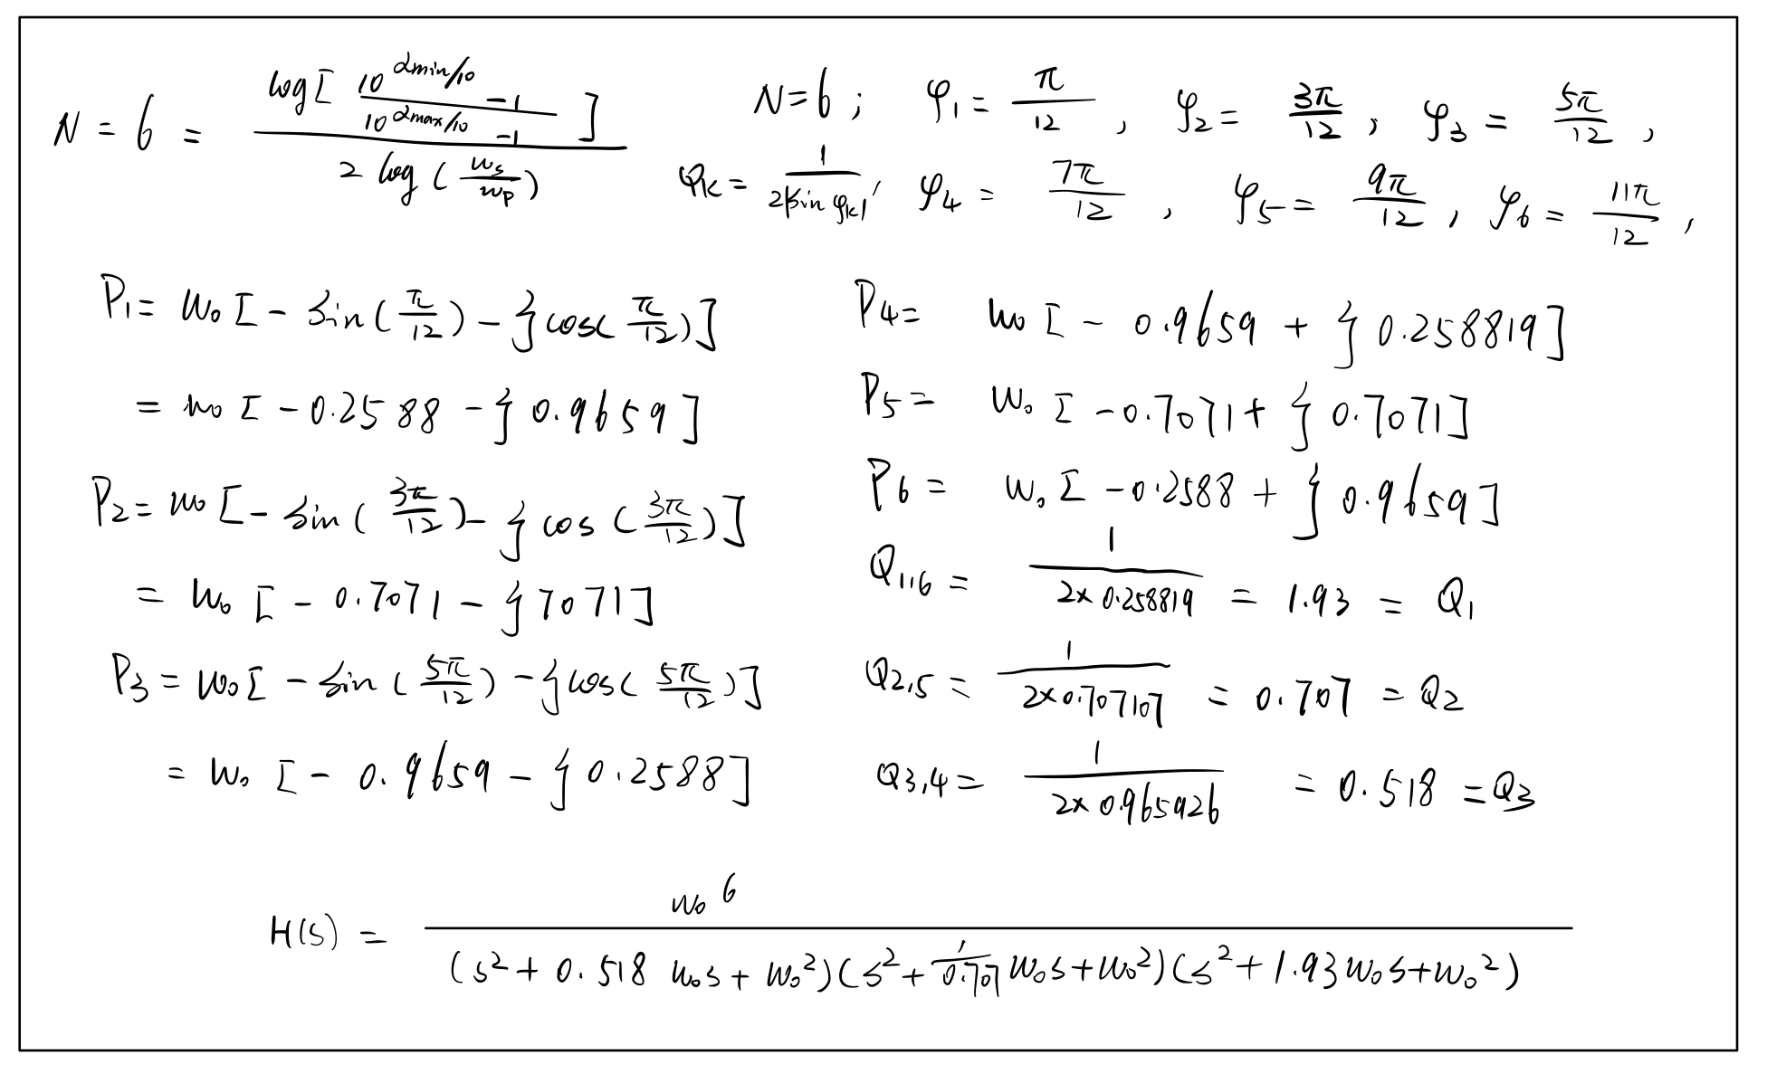

Fig. 1. Calculations for the Butterworth low-pass filter transfer function.

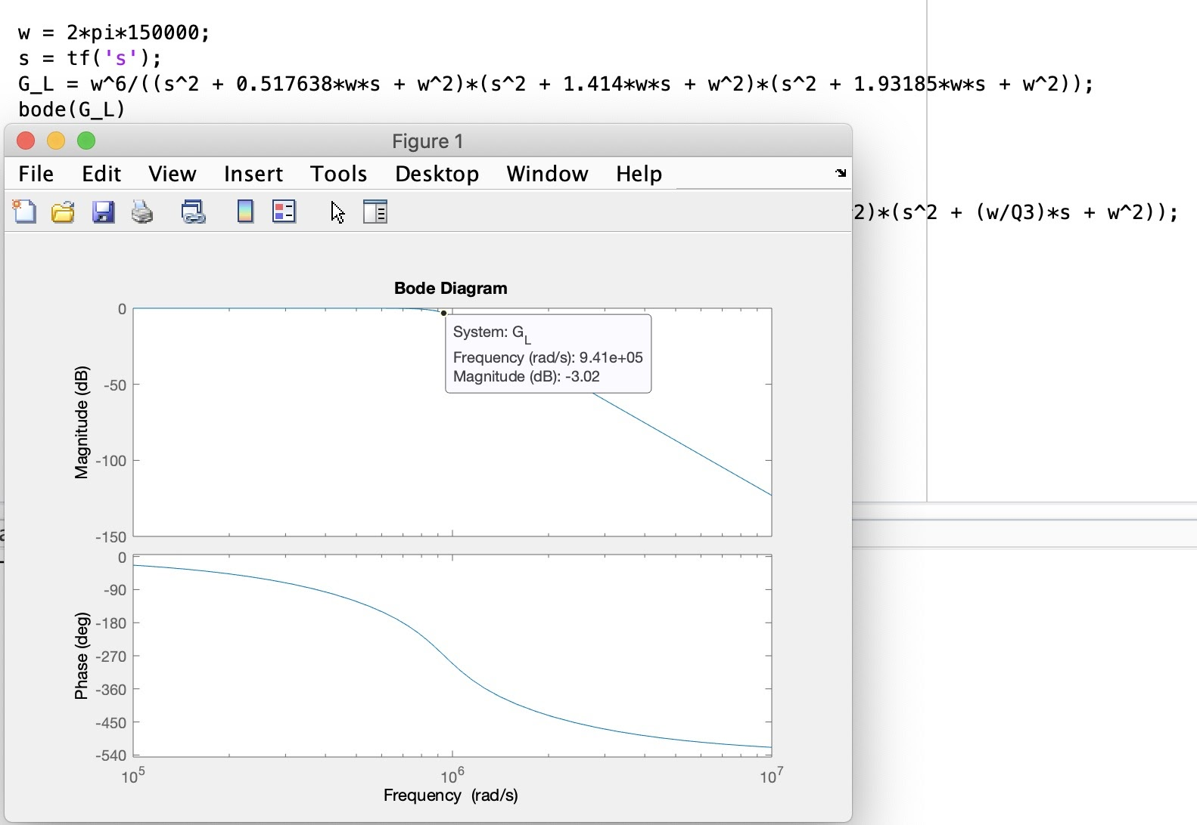

Fig. 2. MATLAB plots of the Butterworth low-pass filter response with a 150 KHz cutoff frequency. The 3dB frequency simulated is 9.41e+05 rad/s = 149.7KHz = 150KHz. The DC gain is 1v/v.

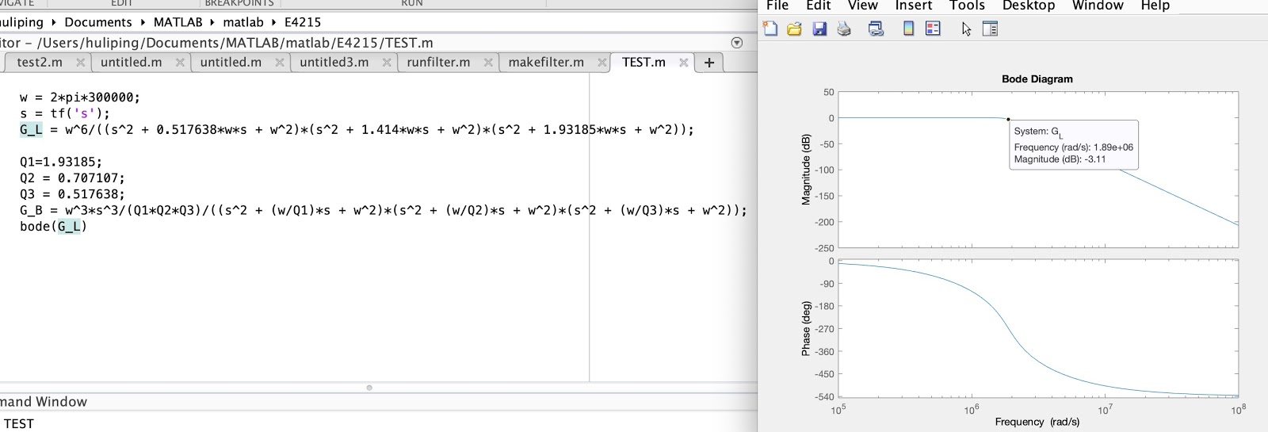

Fig. 3. MATLAB plots of the Butterworth low-pass filter response with a 300 KHz cutoff frequency. The 3dB frequency simulated is 1.89e+06 rad/s = 300KHz. The DC gain is 1v/v.

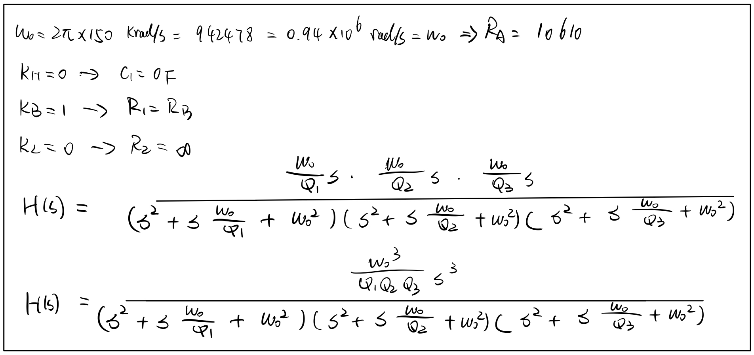

Fig. 4. Calculations for the Butterworth band-pass filter transfer function.

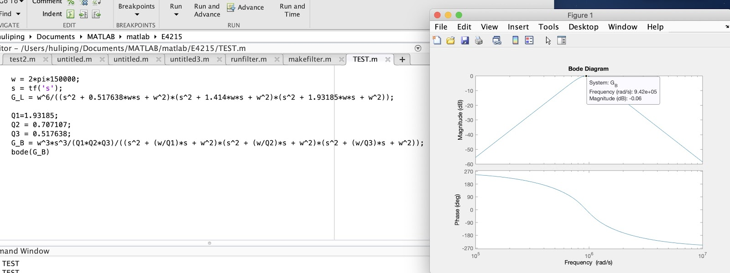

Fig. 5. MATLAB plots of the Butterworth band-pass filter response with a 150 KHz cutoff frequency. The center frequency is 9.42e+05 rad/s = 149.9KHz = 150KHz. The DC gain is 1v/v.

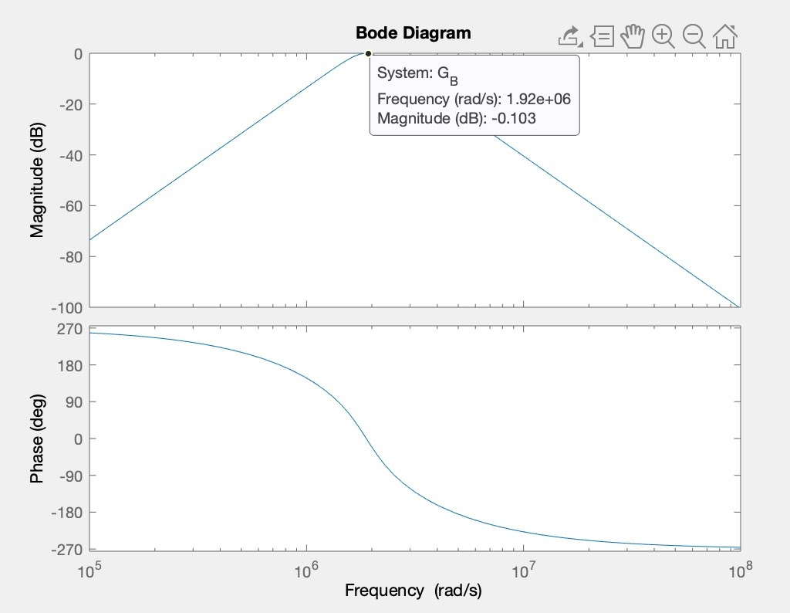

Fig. 6. MATLAB plots of the Butterworth band-pass filter response with a 300 KHz cutoff frequency. The center frequency is 1.89e+06 rad/s = 300KHz. The DC gain is 1v/v.

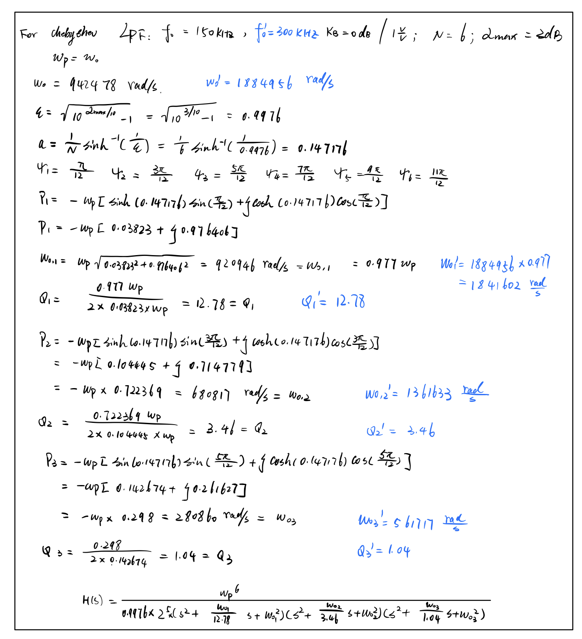

Fig. 7. Calculations for the Chebyshev low-pass filter transfer functions. The blue marked symbols represent corresponding values for 300KHz cutoff frequency.

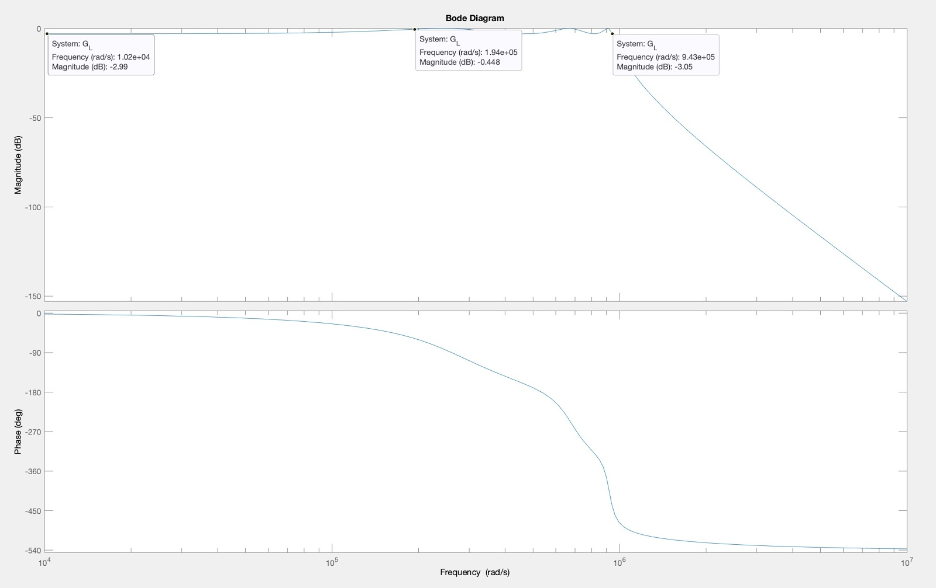

Fig. 8. MATLAB plots of the Chebyshev low-pass filter response with a 150 KHz cutoff frequency. The 3dB frequency simulated is 9.43e+05 rad/s = 150KHz. The DC gain is 1v/v.

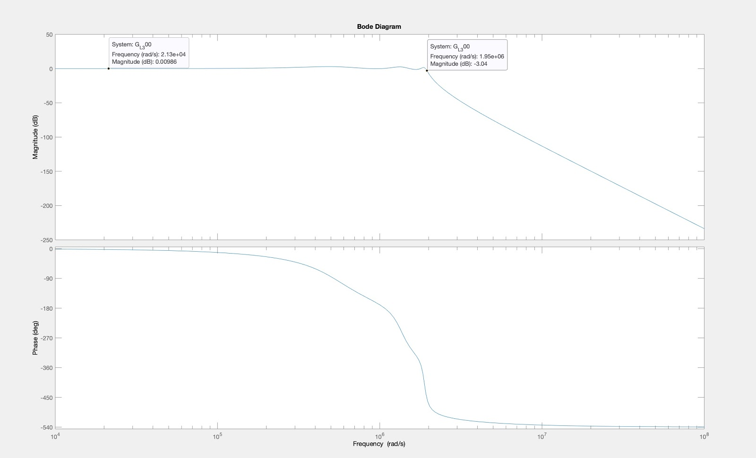

Fig. 9. MATLAB plots of the Chebyshev low-pass filter response with a 300 KHz cutoff frequency. The 3dB frequency simulated is 1.95e+06 rad/s = 310KHz. The DC gain is 1v/v.

# Procedure for Implementing Transfer Function.

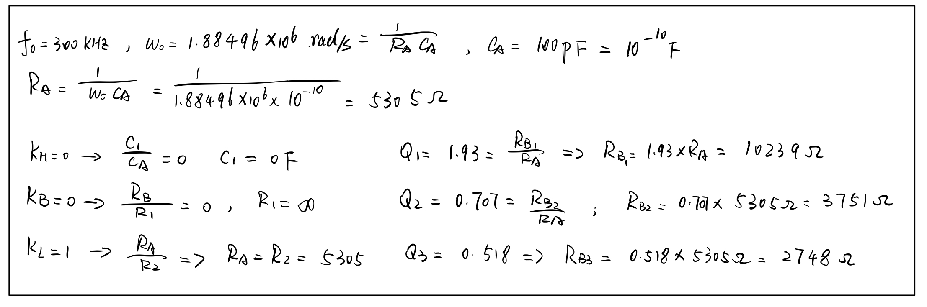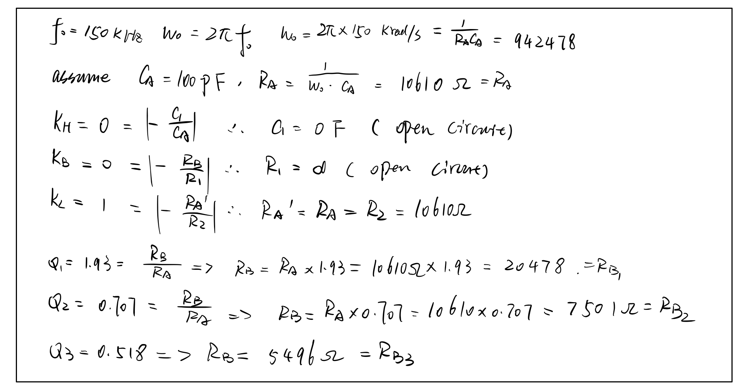

Fig. 10. calculation procedure for determining the resistor and capacitor values for the 6th order low-pass Butterworth filter in terms of cutoff frequency.

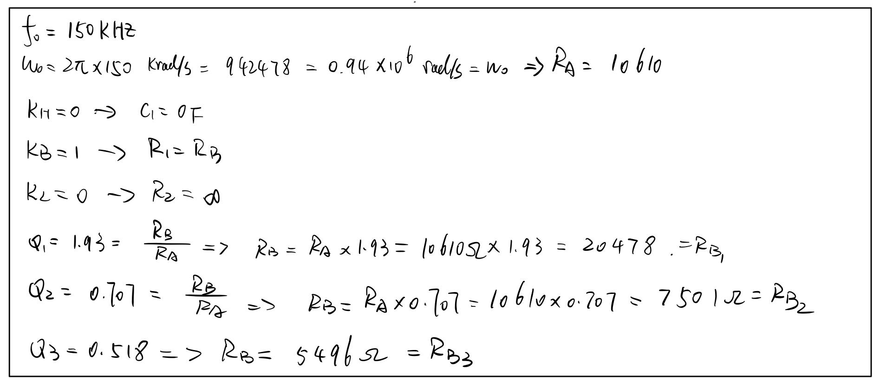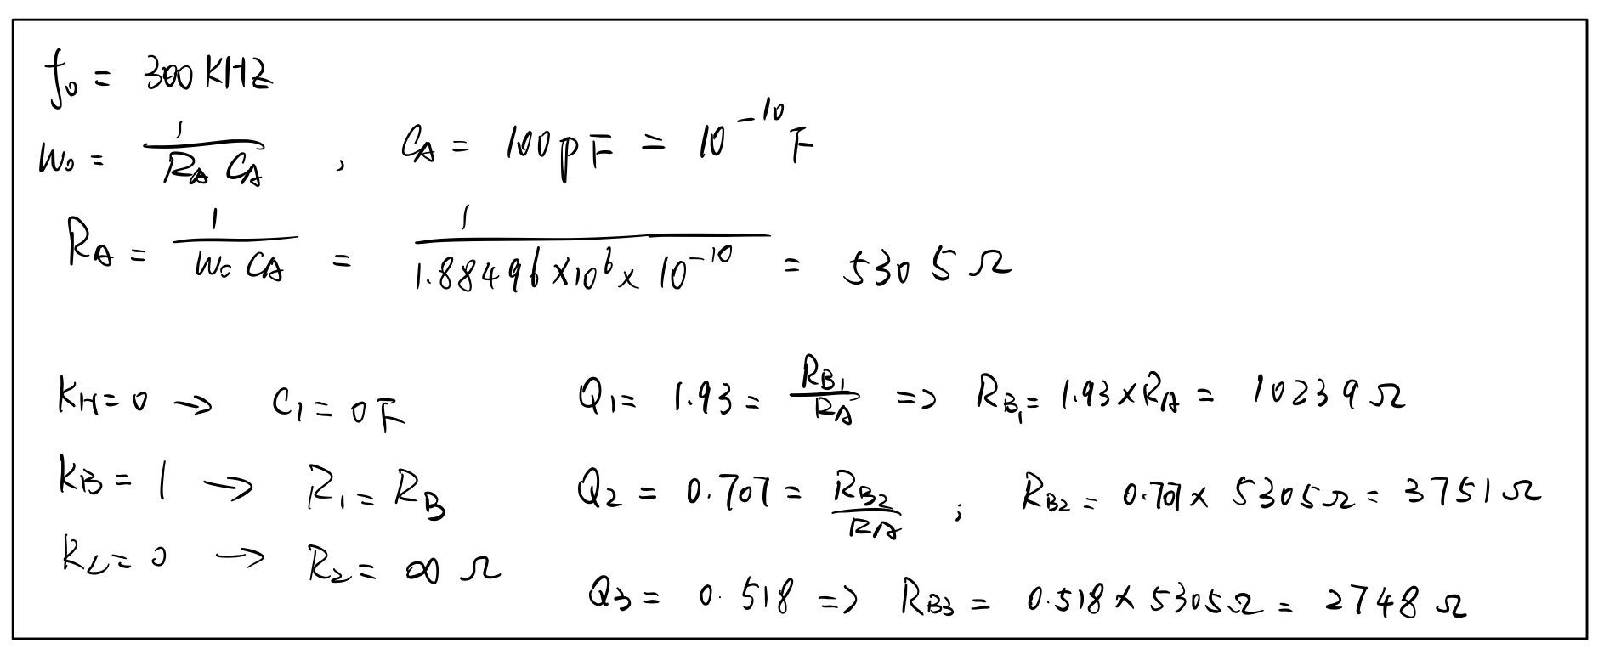

Fig. 11. calculation procedure for determining the resistor and capacitor values for the 6th order band-pass Butterworth filter in terms of cutoff frequency.

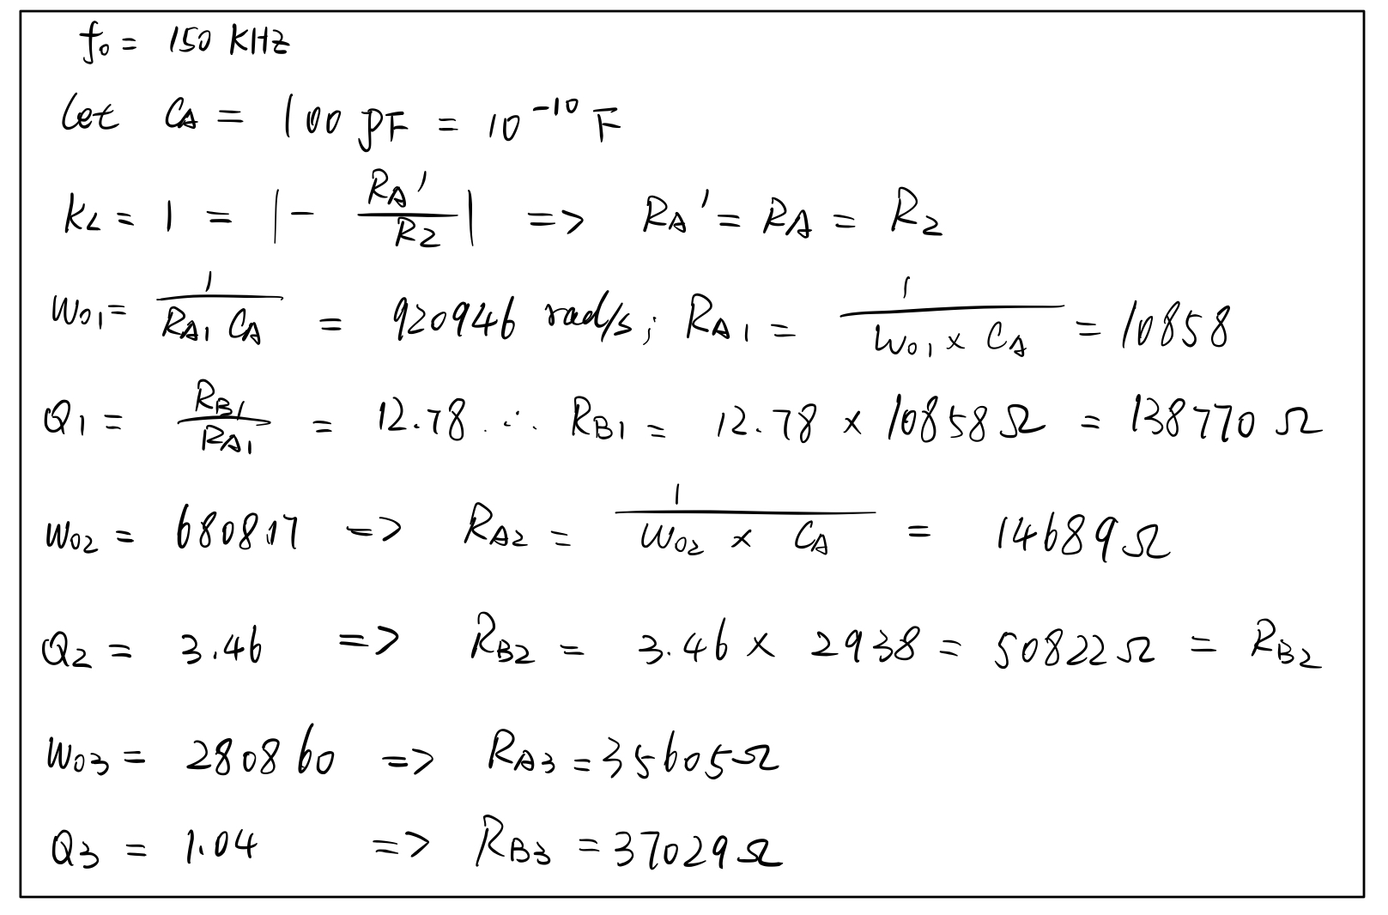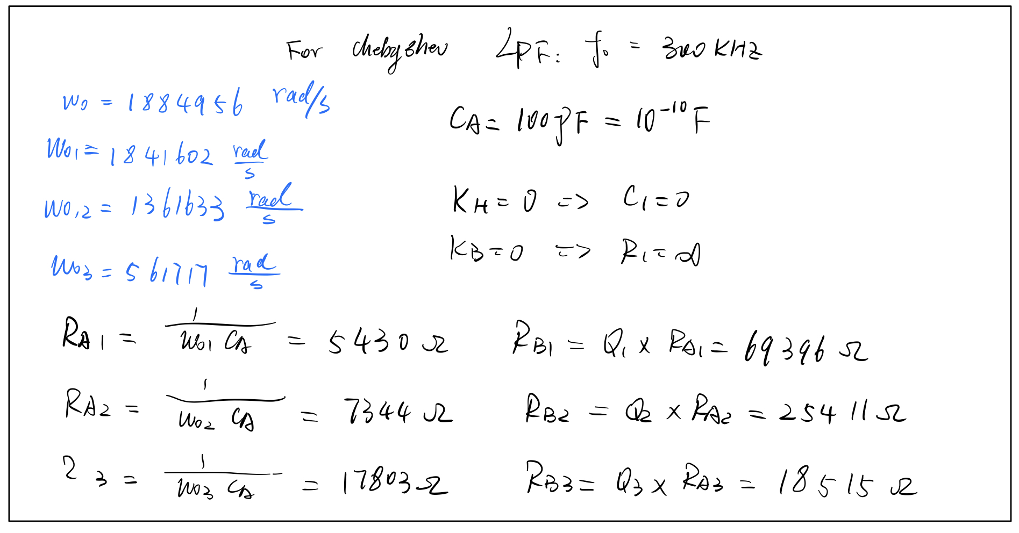

Fig. 12. calculation procedure for determining the resistor and capacitor values for the 6th order low-pass Chebyshev filter in terms of cutoff frequency.

TABLE 1.

Resistor and capacitor values for the programmable anti-aliasing filter design.

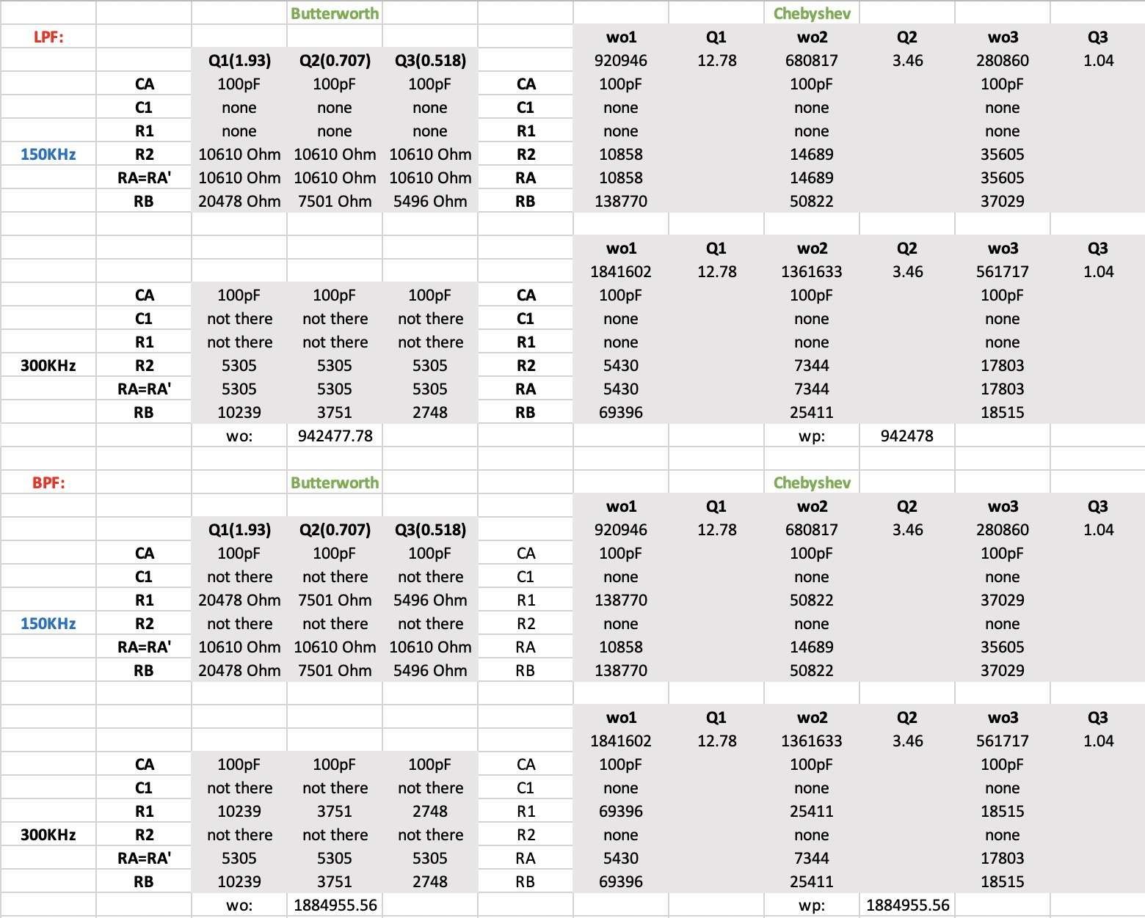

# Subcomponents

## Analog Multiplexers

Analog multiplexers are needed in our design to select the wanted filter response. We have utilized the 2-to-1 multiplexer topology given in the course. (Fig. )

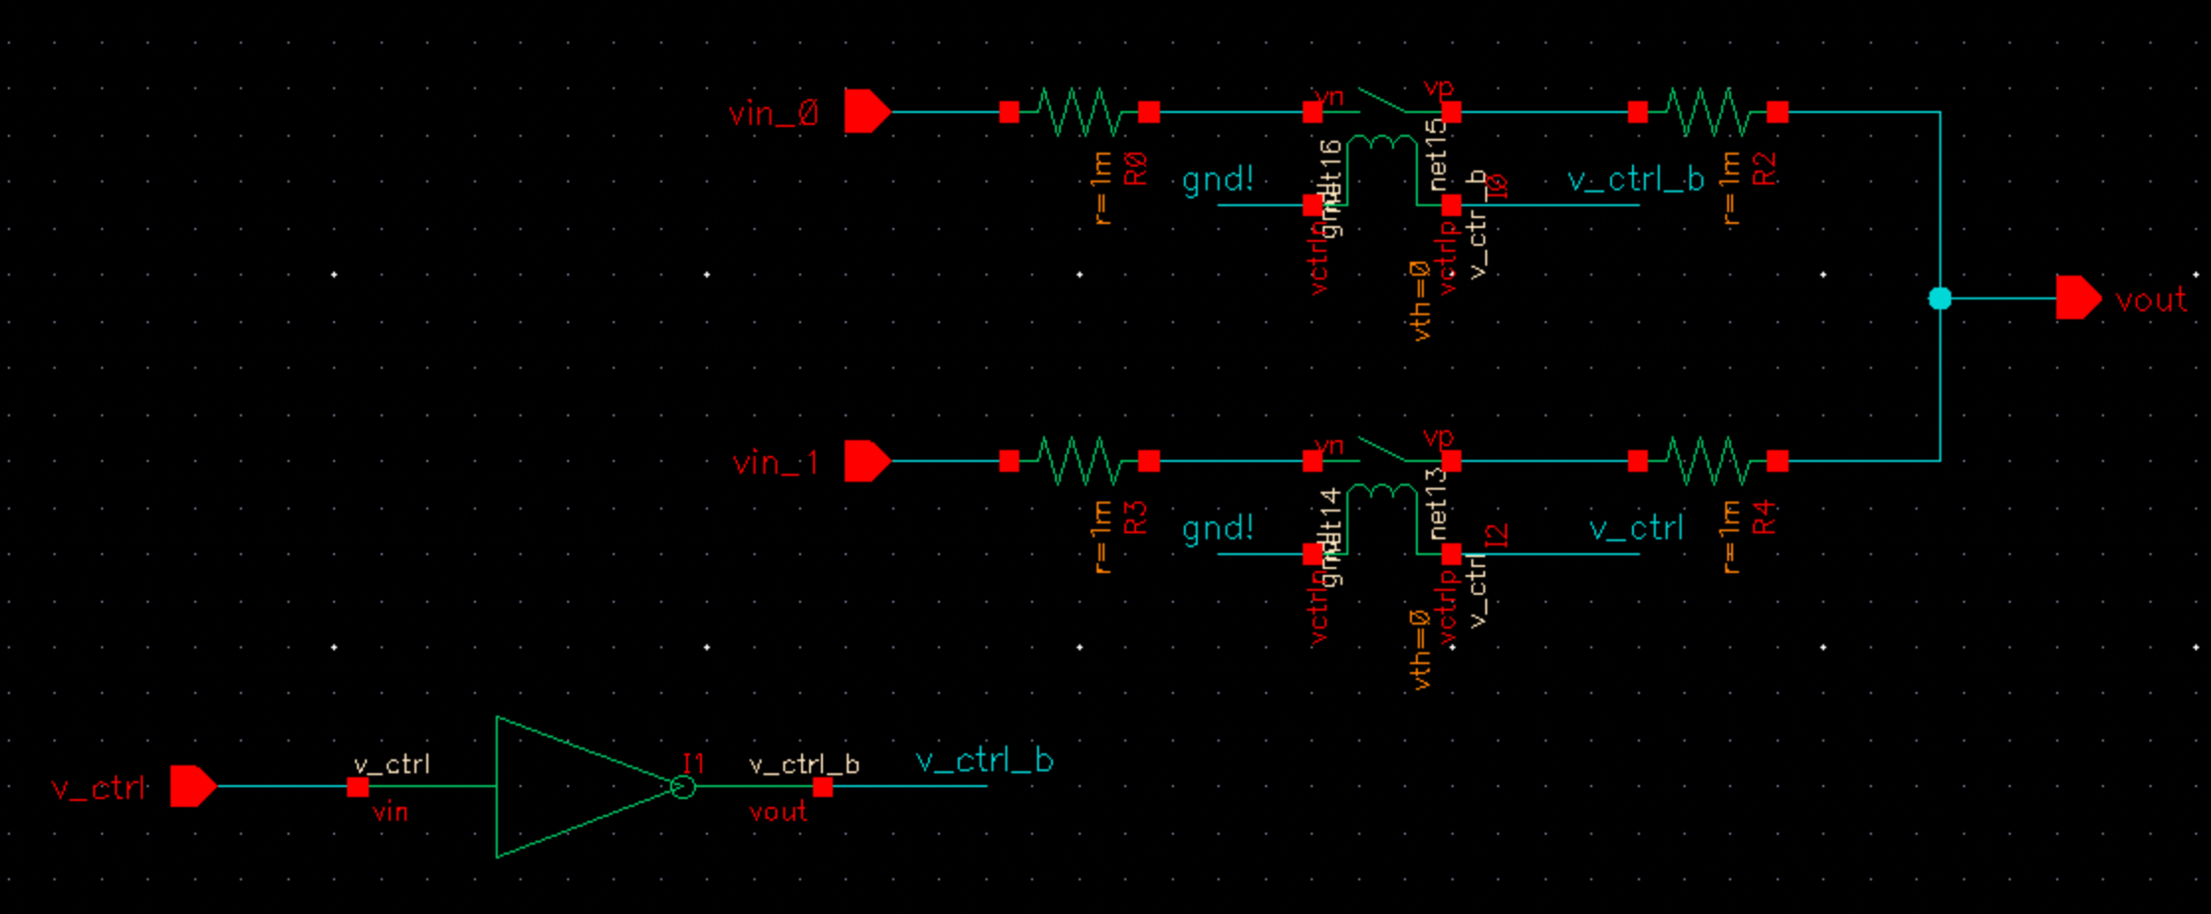

Fig. 13. 2-to-1 MUX

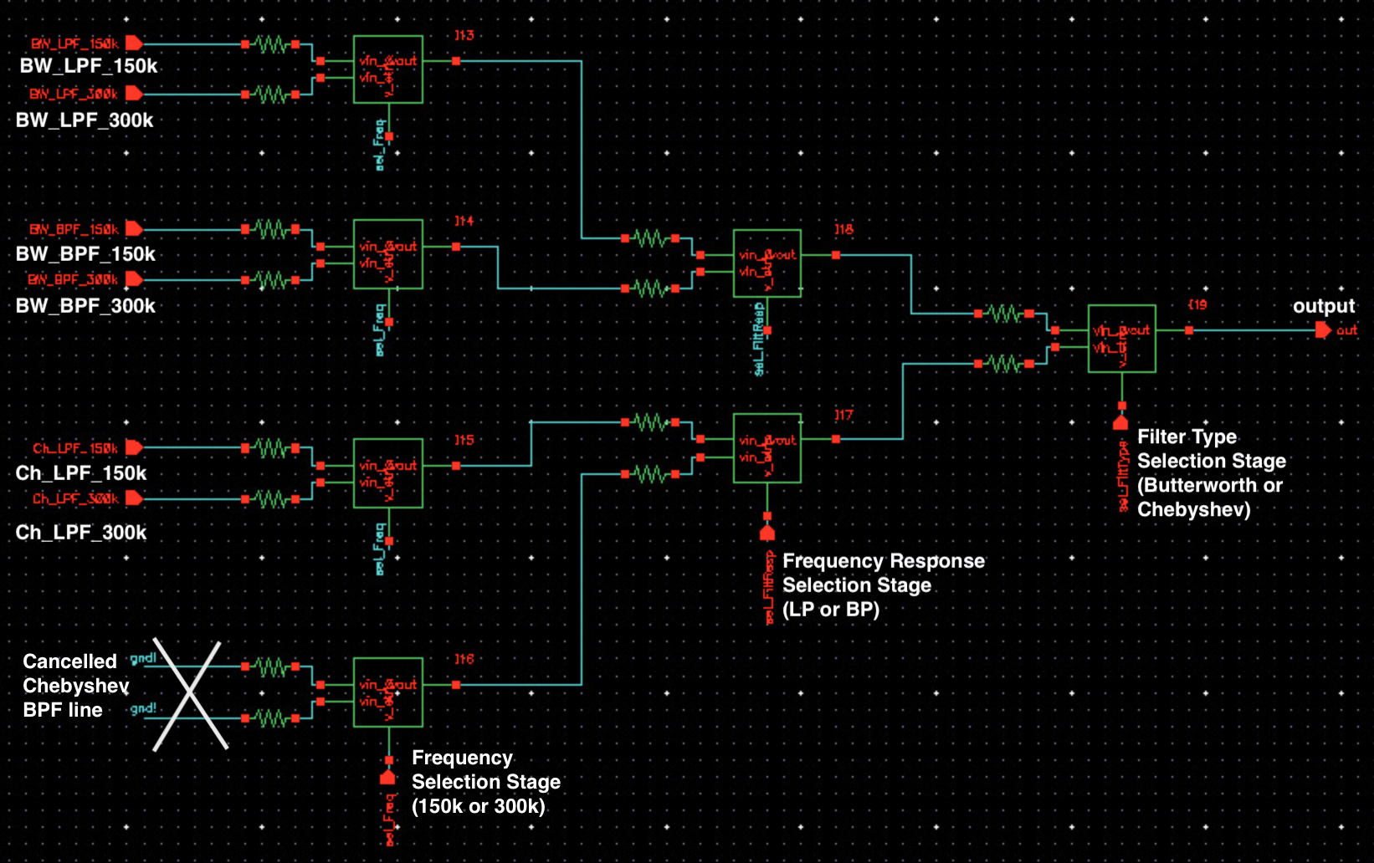

Fig. : 8-to-1 MUX

Fig. 14. This multiplexer design has been cascaded to create an 8-to-1 MUX. This 8-to-1 MUX is used to choose the resistor values necessary for particular filter response. An example of this selection is provided in Fig. .

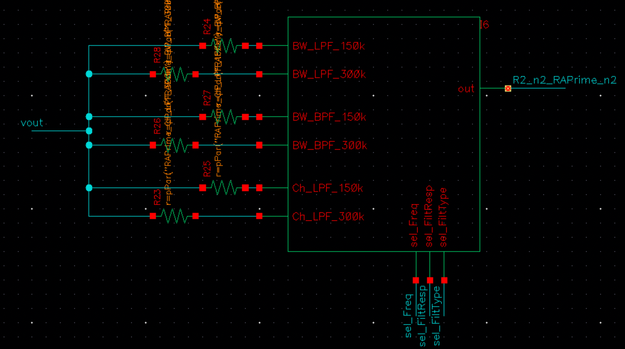

Fig. 15.

## Operational Amplifier

A simple operational amplifier model is designed for our system. In order to meet the specifications given in the project description, we determined the gm, Io,max, Rin, C1, A2, Output swing and Rout.

We started the analysis with gm calculation, assuming C1 = 50 pF. Unity gain frequency formula $w_{t}={g_{m}}/{C_{1}}$ is used to calculate a rough estimate for the gm. In order for $w_{t}$ to not interfere with the passband of the filter, we should have gm in the order of mS.

After determining the rough estimate, a parametric sweep is performed to fine tune the gm. This parametric sweep is used to determine a value while considering the trade-off between better frequency response and low power consumption since gm is affecting both parameters. Fig. shows us this trade-off when gm is swept between 1 mS and 10 mS.

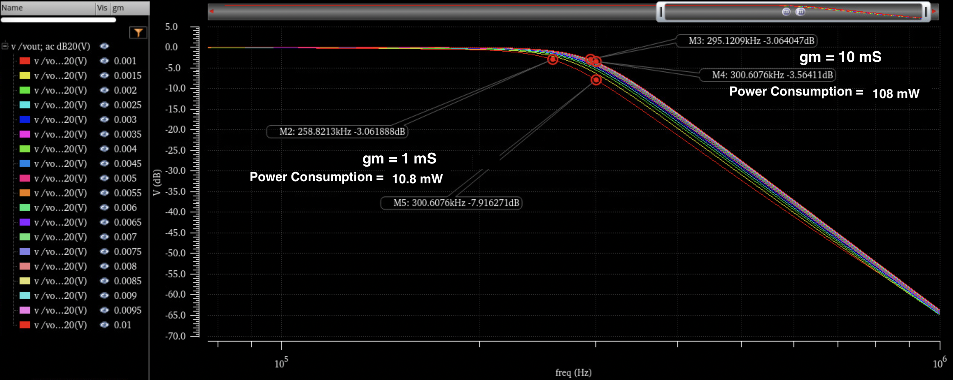

Fig. 16: Parametric Analysis to determine gm

Above figure includes power consumption estimates by using the Io,max value that is calculated by using the specification Io,max/gm = 200 mV.

$$g_{m}=4 mS$$

$$I_{o,max}=±800 μA$$

In addition to these specifications, we should calculate the DC gain of our opamp along with other parameters:

$$DC Gain=A_{2}*g_{m}*R=104 dB$$

$$f_{p}=\frac{1}{R C_{1}A_{2}*2π }=500 Hz$$

Since our opamp has a single pole, there will be a 20 dB/dec slope during the degrade of the gain while frequency increases. At 500 kHz, we would still have a 44 dB gain for the opamp which will not interfere with the operation of our programmable filter.

$$f_{t}=\frac{g_{m}}{ C_{1}}=80 MHz$$

The latest form of the opamp is demonstrated in Fig. .

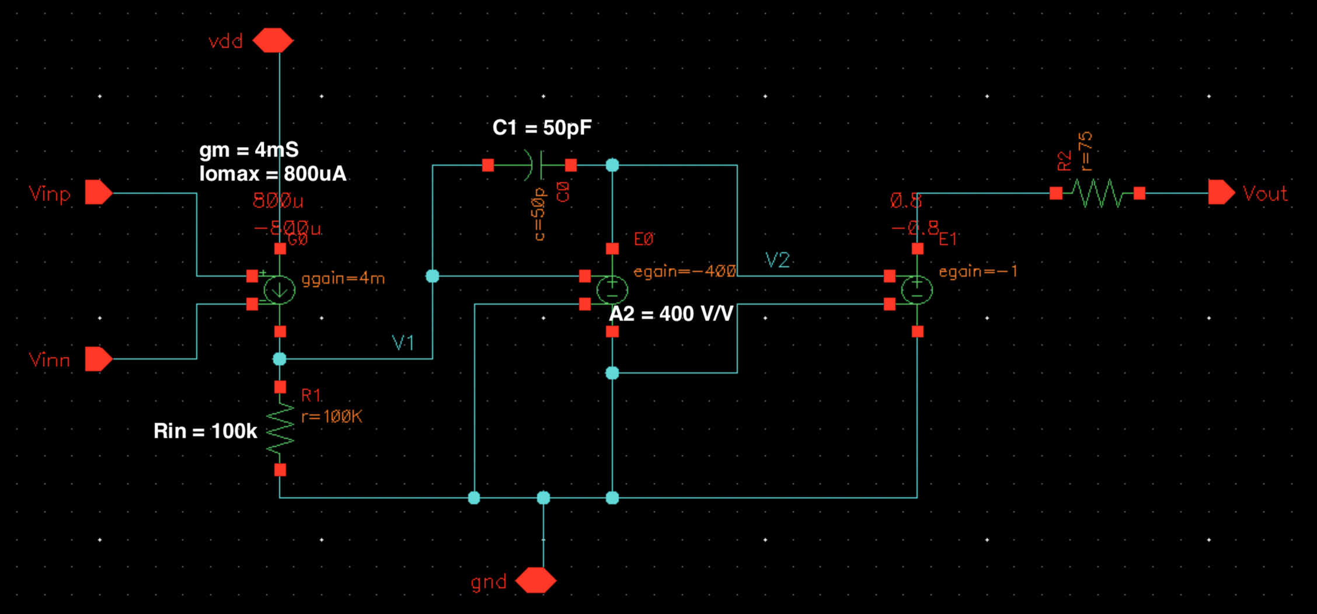

Fig. 17. Operational Amplifier Design

# Schematics

In our filter, we have utilized the generic Ackerberg-Mossberg biquad to create a second order response that can produce all filter responses. (Fig. )

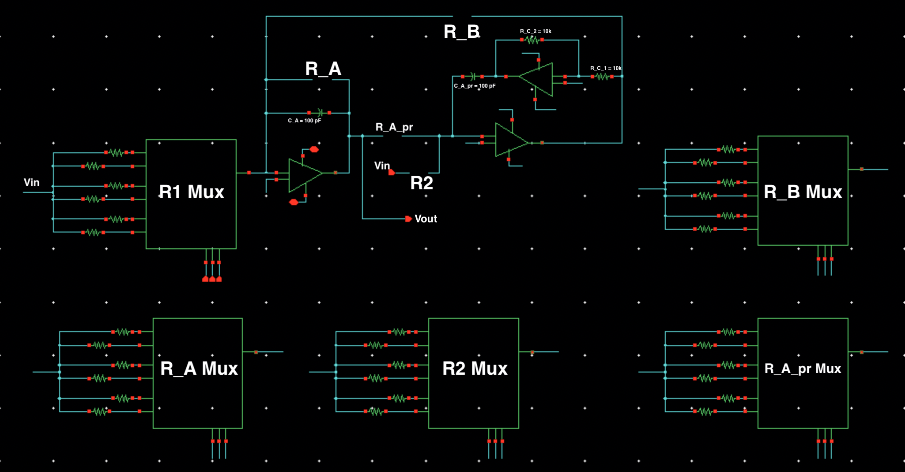

Fig. 18. Generic Ackerberg-Mossberg Biquad along with resistor multiplexing

Only some of the resistors are changing values from one design to another. Capacitors are chosen as 100 pF. Positive feedback loop’s resistors are also fixed to 10 k $Ω$. For low-pass and bandpass response, most of the components are the same but some of the components are changing from one to another. Hence, since we’re using only a single generic schematic, we performed the open-circuit as a 1 T $Ω$ resistor value if that resistor is not used for that topology.

In order to create a sixth order filter response, three biquads are cascaded as shown in Fig. . The resistor values are entered as a pParameter and shown in this figure. To account for the resistor associated with the multiplexers, we used the resistor values 300 $Ω$ less than the ones calculated in our table.

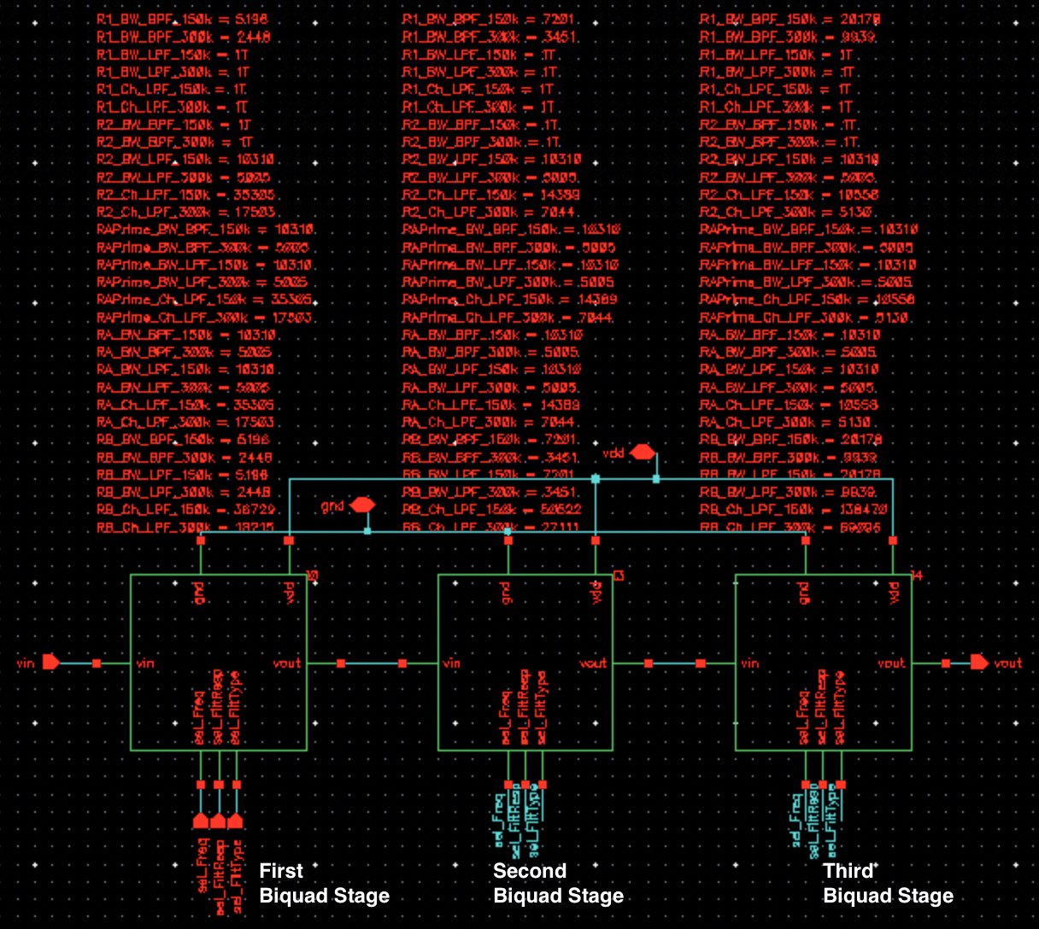

Fig. 19. Generic 6th Order Biquad along with resistor values as a table. The select lines are used to choose the filter response wanted.

# Simulation Results

## Frequency Response

Frequency responses of individual filter behavior are presented in this section with six different bode plots. Butterworth filters show us a perfectly smooth flat response while the Chebyshev filters have ripple in the passband.Here, the gain increases up to 3.9 dB from 0 dB DC gain.

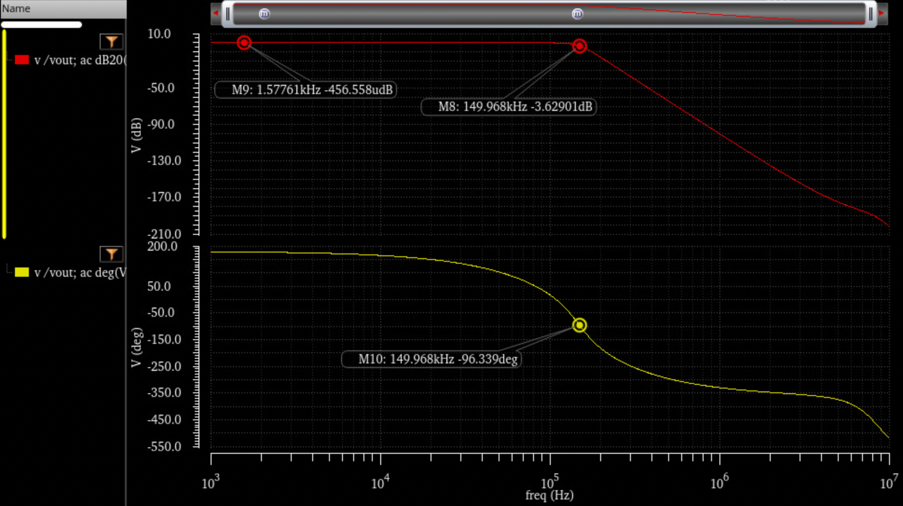

Fig. 20. Butterworth LPF with 150 kHz Cut-off Frequency

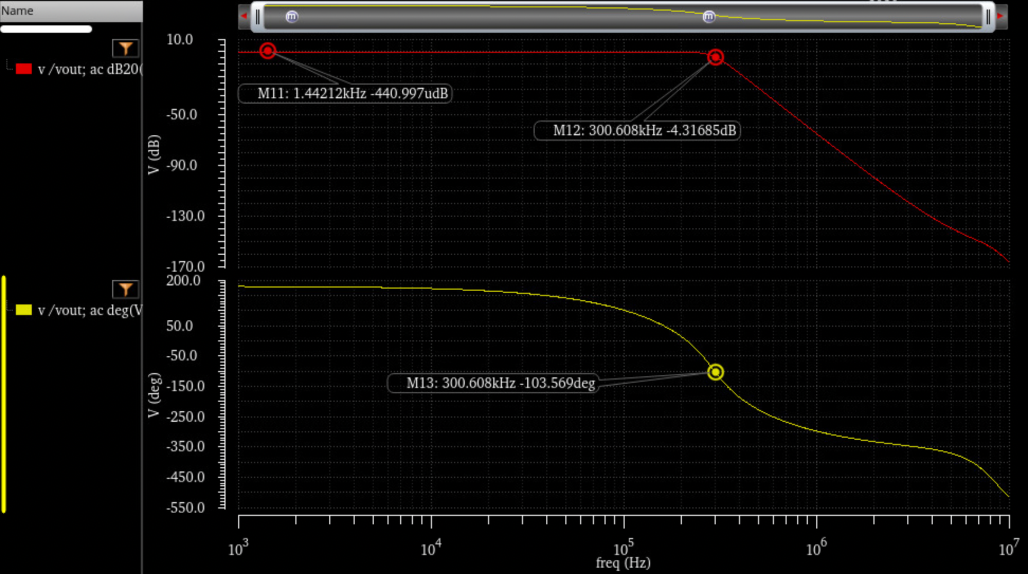

Fig. 21. Butterworth LPF with 300 kHz Cut-off Frequency

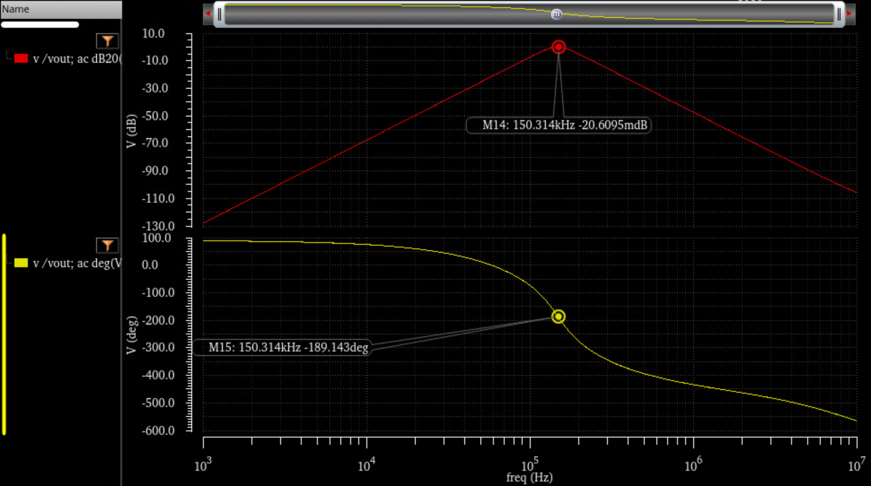

Fig. 22. Butterworth BPF with 150 kHz Center Frequency

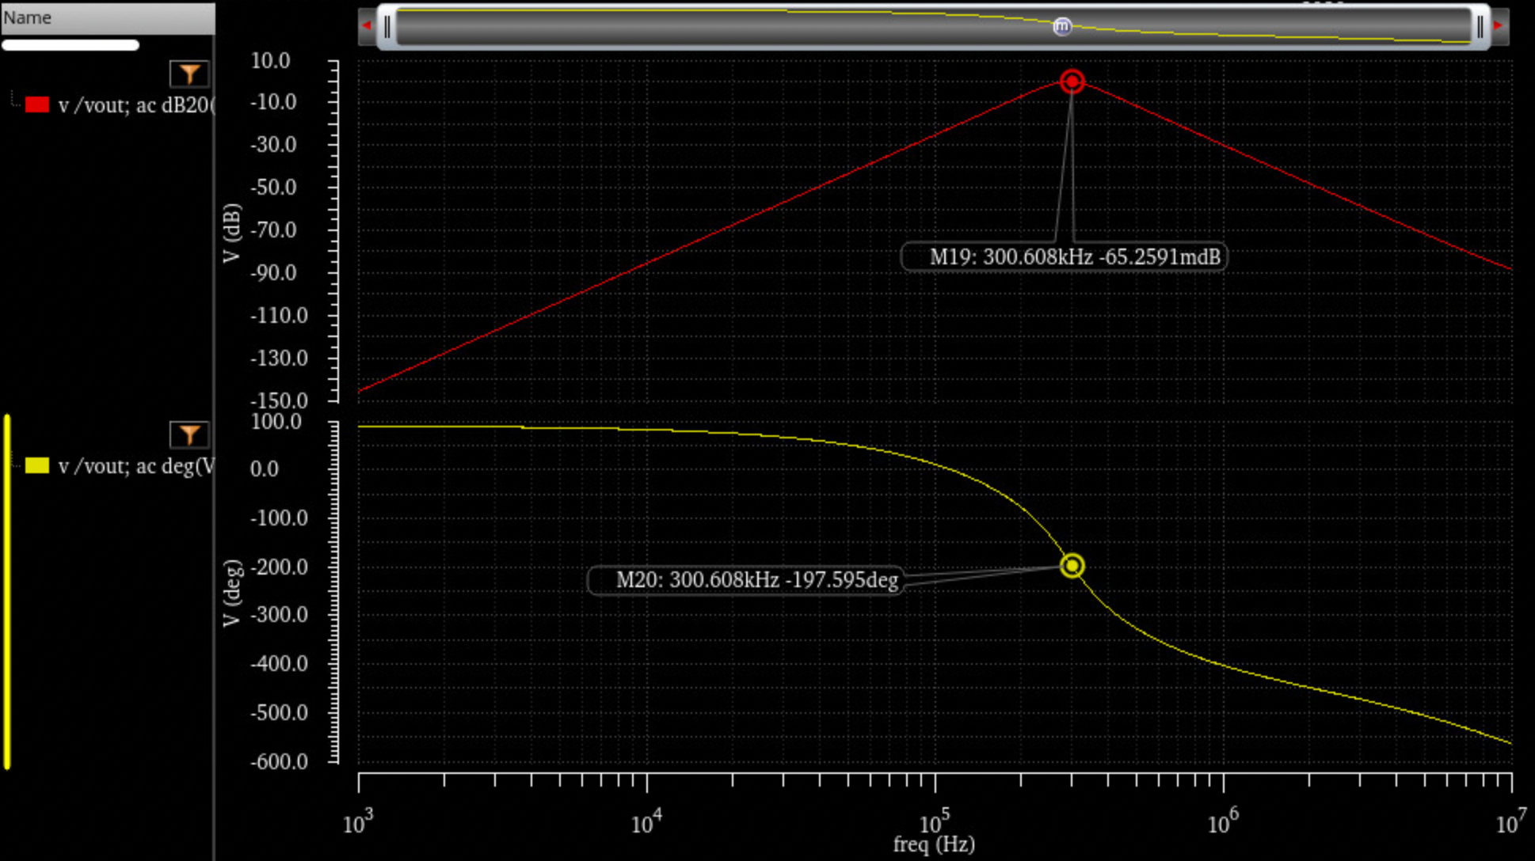

Fig. 23. Butterworth BPF with 300 kHz Center Frequency

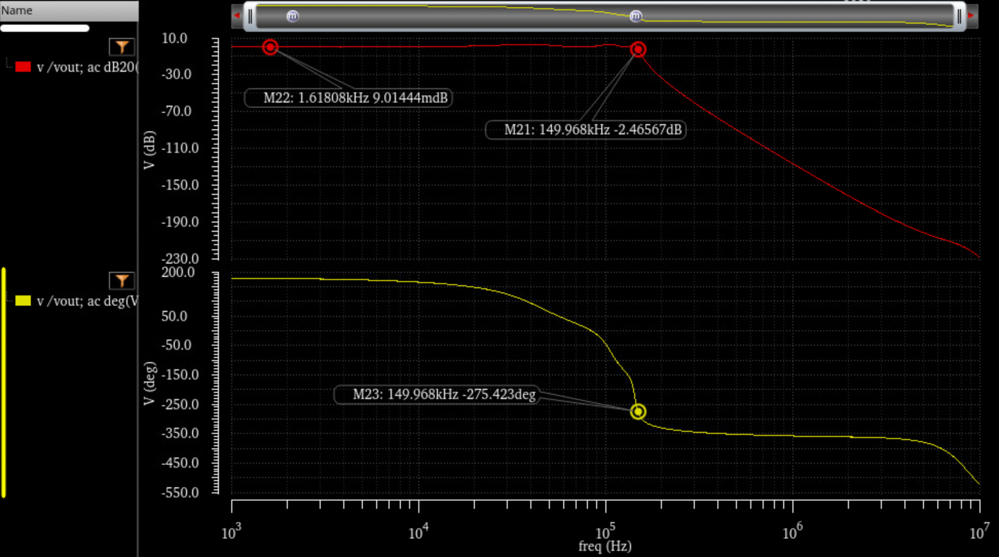

Fig. 24. Chebyshev LPF with 150 kHz Cut-off Frequency

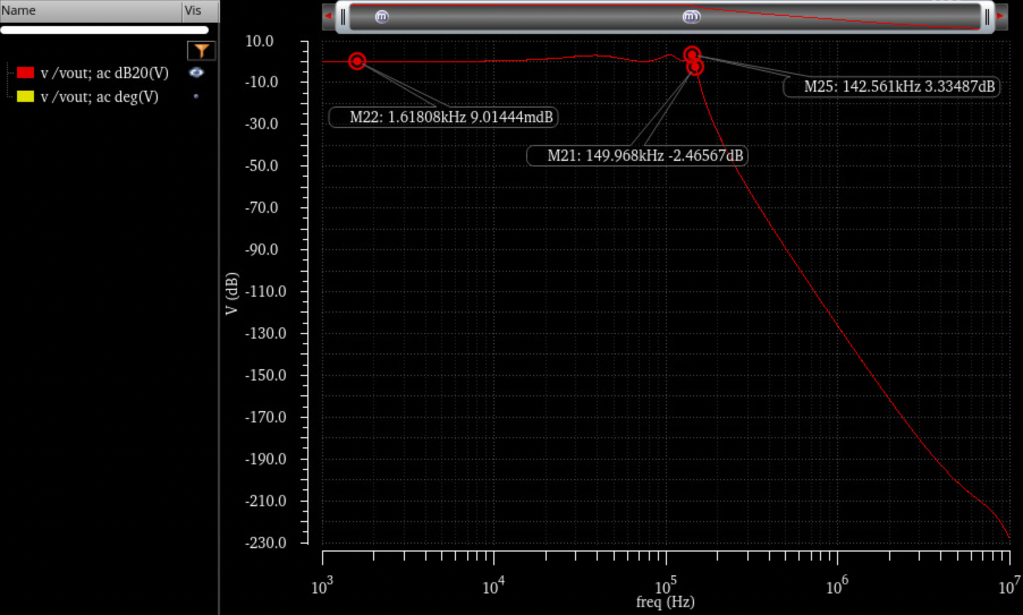

Chebyshev LPF with 300 kHz Cut-off Frequency

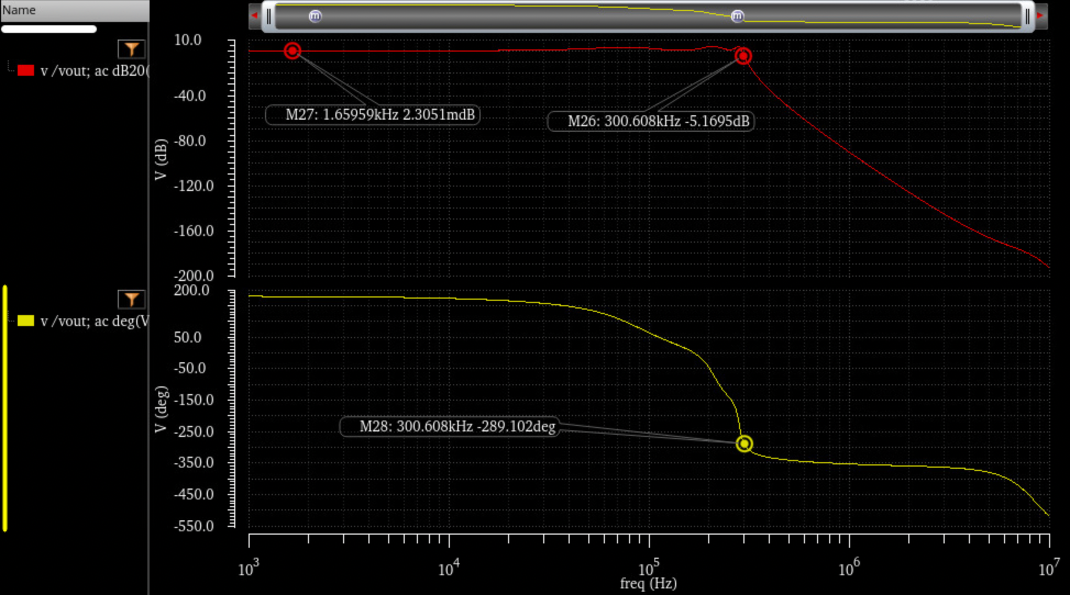

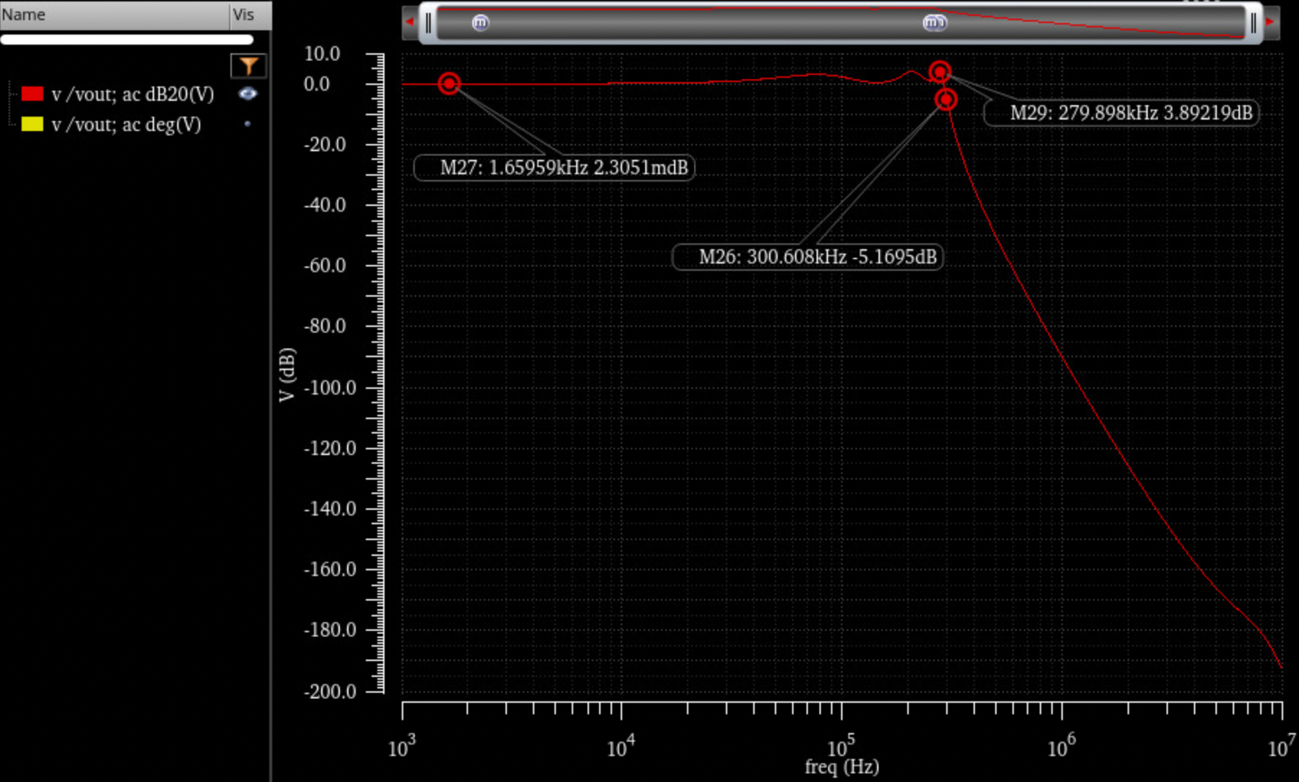

## Transient Simulations to show adequate slew rate

Slew rate requirement for the opamp is calculated by using the highest frequency of operation (300 kHz) and output swing (0.8 V). This specification requires us to have a slew rate of 0.24 MV/s.

A transient analysis is performed on the opamp to prove that our design satisfies the slew rate requirement. For this analysis, a new test bench is created where the opamp is in voltage buffer mode and a pulse voltage source is applied at the input. (Fig. )

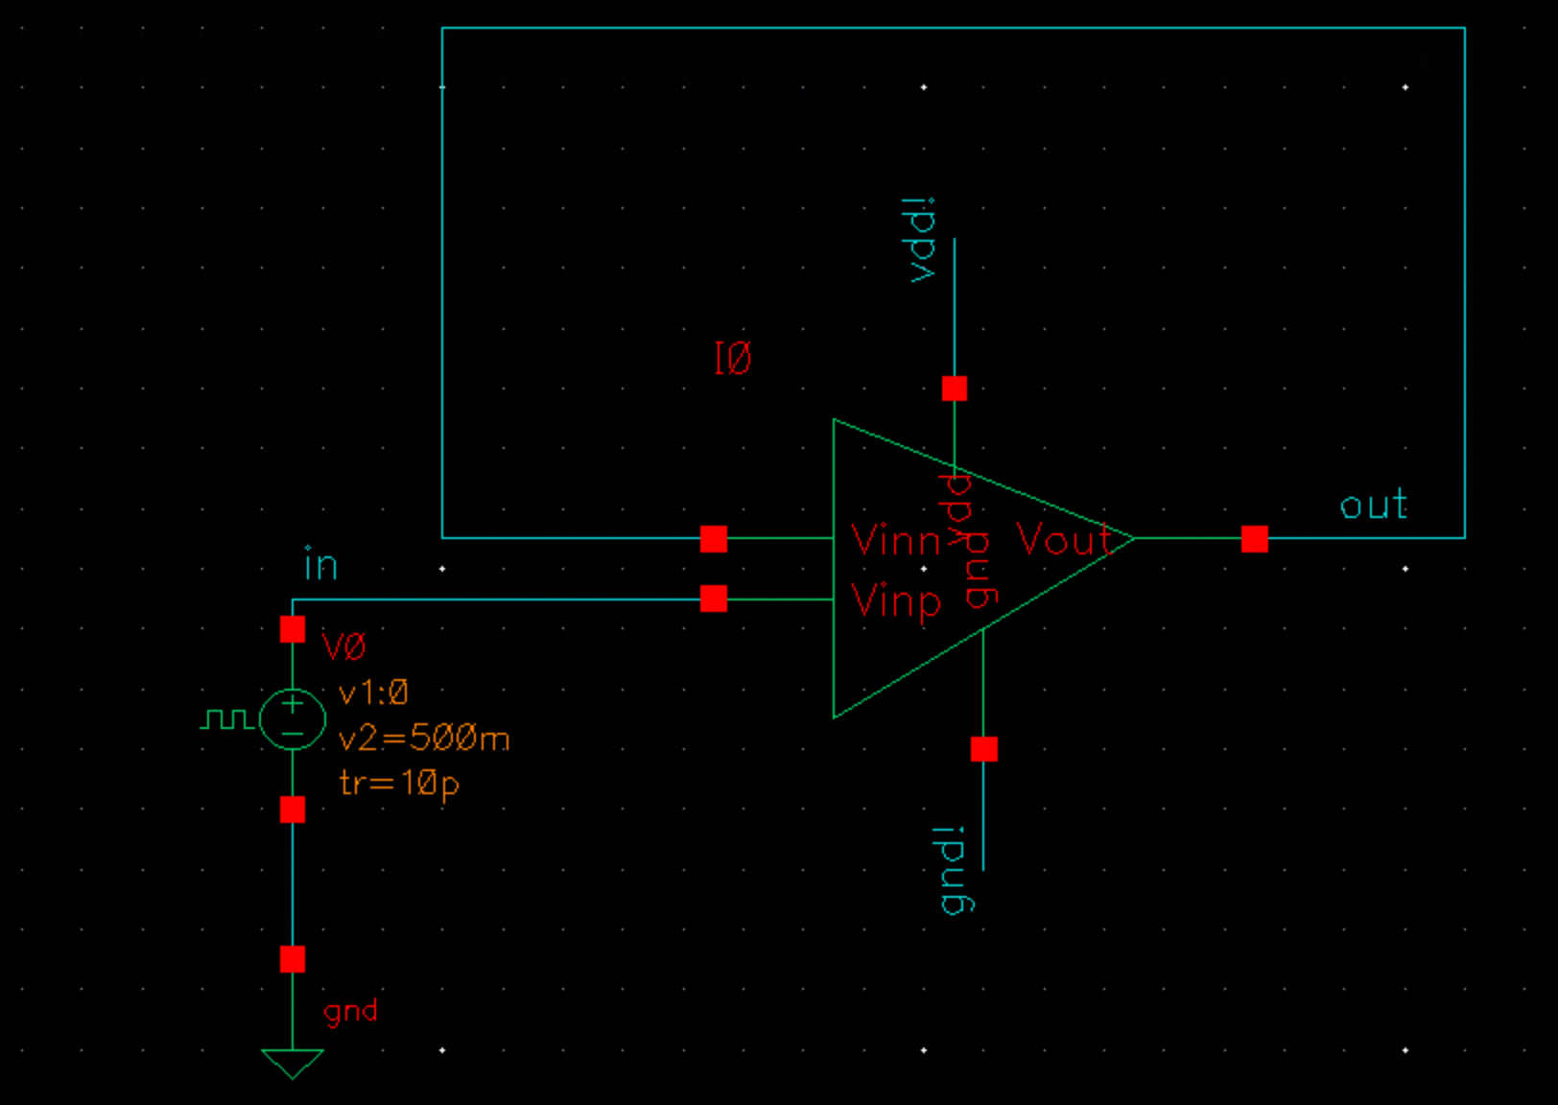

Fig. : Slew Rate transient analysis test bench

With this test bench, we expect to see that output will follow the input pulse waveform. However, because of the slew rate limitation that our design has, there will be a latency between the input waveform and the output waveform. This has been shown in Fig. .

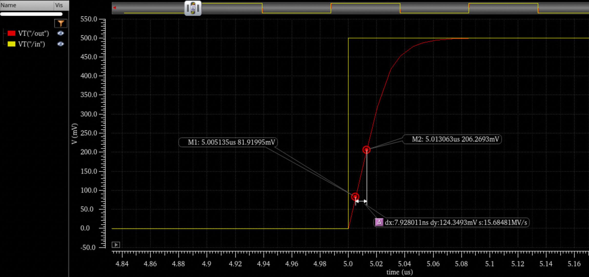

Fig. Slew rate transient analysis waveforms

With this analysis, we see that we meet the slew rate requirement of 0.24 MV/s with a slew rate of 15.68 MV/s.

## Power Consumption

Power calculation is performed by using the simplified formula for our opamp topology.

$$Power_{SingleOpamp}= I_{o,max}*(V_{dd}-V_{ss})*3$$

$$Total Power= Power_{SingleOpamp}*9$$

Supply voltage levels are given as:

$$V_{dd}=1 \& V_{ss}=-1$$

Thus, the total power consumption of the 6th order filter is calculated as:

$$Total Power=43.2 mW$$

## Table for Figures of Merit

|  |  |
| --- | --- |
| **Parameter** | **Value** |
| Opamp gm | 4 mS |
| Opamp Io,max | 800 $μA$ |
| Opamp Slew Rate | 15.68 MV/s |
| Opamp DC Gain | 104 dB |
| Opamp fp & ft | 500 Hz & 80 MHz |
| Power Consumption | 43.2 mW |

## 

1. Submitted on 12/18/2020 as a report for the final design project of the E4215 at Columbia University in the City of New York by:

   Liping Hu, [lh3009@columbia.edu](mailto:lh3009@columbia.edu)  
   Sinan Yilmaz, [sy2943@columbia.edu](mailto:sy2943@columbia.edu)